DEVELOPMENT OF TOKEN AUTHENTICATION AND USER MANAGEMENT FOR SMART AGRICULTURE

Summary of Thesis
For partial fulfillment of the requirement
for the Degree of Master
Master of Electrical Engineering
Department of Electrical Engineering and Information Technology


Proposed by
Arif Setiawan
13/356785/PTK/9213

To

POSTGRADUATE SCHOOL

FACULTY OF ENGINEERING
UNIVERSITAS GADJAH MADA
YOGYAKARTA
2017
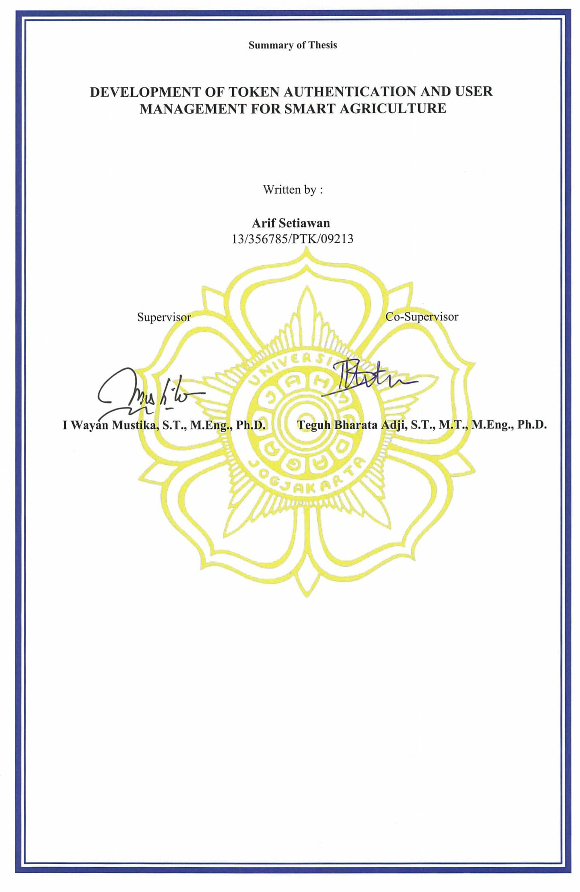

ABSTRACT
Nowadays, The Internet of Things (IoT) sensor which can be set to collect data every minute and second make the IoT be the first choice for systems that require continuous monitoring. One of the most common data communication methods applied to IoT is Representational State Transfer (REST). REST has the advantage of being able to support different standard devices. However, the security aspect has not been a major concern in this topic. In this research, REST authentication system will be developed by using token based mechanism on smart agriculture system. In every request that occurs, the client must include a registered token for the request can be served. In addition, user management will also be implemented based on user roles. Access from user to resource will be limited based on their role to improve the security of data. This research show thaty, the created system can improve the security aspects of IoT applications based on REST communication especially on smart agriculture system.
Keyword: REST, web service, internet of things, authentication, role based access control

TABLE OF CONTENT
ABSTRACT iii
TABLE OF CONTENT iv
CHAPTER I INTRODUCTION 1
1.1 Background 1
1.2 Research Objectives 2
CHAPTER II LITERATURE AND THEORETICAL 3
2.1 Literature Review 3
2.2 Theoretical Basis 4
CHAPTER III METHOD 7
3.1 Tool and Material 7
3.1.1 Tool of Research 7
3.1.2 Material 7
3.2 Research Flow 7
1. System Requirement Analysis 7
2. System Planning 8
CHAPTER IV RESULT 10
4.1 Result 10
CHAPTER V SUMMARY AND SUGGESTION 12
5.1 Summary 12
5.2 Suggestion 12
BIBLIOGRAPHY 13

CHAPTER I
INTRODUCTION

1.1 Background
Internet Of Things (IoT) became one of the most talked-about technologies today. Its rapid progress and deployments that can be used in all areas make IoT one of the most developed technologies. According to study results from Gartner [1], a research and technology company from the United States. By 2017 there will be 1.5 billion new devices connected to the internet. The amount will increase to 20 billion devices by 2020.
At the end of 2016 yesterday, Dyn a provider of Domain Operated Systems (DNS) experienced DDOS attacks on their servers. This has resulted in large sites using DSN Dyn services such as Amazon, Airbnb, CNN, Netflix and Spotify not accessible to users. After a thorough investigation, it was found that the attack was carried out over 100,000 IoT devices affected by Mirai botnet malware [2].
Based on the above, the security side of IoT needs to be improved so that the case does not reoccur. Either from the side of the device itself, data communication or from the middleware side. Middleware is a liaison between components in IoT so that each component can communicate. In its implementation, middleware can be applied in the form of Application Programming Interface (API). API is a link between the backend and frontend. In the development of IoT-based applications, APIs serve as a liaison system between the sensor with the database, or the database with the application interface. Use of API is implemented in web service form. The first generation of web services introduced is the Simple Object Access Protocol (SOAP) but due to the growing number of IOT devices and SOAP are not able to handle different devices of standards SOAP usage is becoming obsolete. Representational State Transfer (REST) ​​becomes the next development of web service. REST web service / RESTful has the advantage of being able to support different standard devices because it uses the base of Resource Oriented Architecture (ROA) [3].
REST protocol is widely used as a data communication standard on IoT systems, among others, in the field of smart agriculture. One area of ​​smart agriculture using RESTful is Smart Farm [4]. At Smart Farm, IoT devices are used as a monitoring tool for oil palm plantations that can be accessed through http://smartcity.wg.ugm.ac.id/webapp/smartfarm/index.php. There are 4 main parts in this system are: Sensor Node, Gateway, Back End and Front End. Node sensors will monitor environmental conditions and take data in the form of air temperature, soil temperature, soil moisture, humidity, sunlight intensity, rainfall, wind direction, wind speed, water level and palm oil leaf moisture. These data will be sent wirelessly through the gateway that will be stored into the Back End or database. In order for data from the database can be well visualized then the need for Front End service or Information System. To bridge between Back End and Front End it is necessary to develop API using REST protocol. API in Smart Farm system has 2 functions that is as a link between the sensor node with the database and liaison between the data base with the Information System.
In this Smart Farm system, REST has been well developed but still has some shortcomings because in the development of its system data security aspect has not become a priority. For example, there is no user authentication when accessing the API, so if the URI address of the API is known then it is accessible to everyone. Another problem is that each user can see all the data in the database. Whether it's data from public node sensors or other user node sensor data. For that purpose, this study aims to build authentication services to perform user validation and user management services to manage and restrict the permissions of the user itself.

1.2 Research Objectives
The aim of this study is :
1. Implementation of authentication methods on Smart Farm API based on token mechanism
2. Create user management based on user role on resource in Smart Farm system

CHAPTER II
LITERATURE AND THEORETICAL

2.1 Literature Review
The first research to be the reference in this study was conducted by Dunlu Peng et al [5]. In this study the first time used token as a substitute for username and password to authenticate. The token used is called UsernameToken because it implements the implementation of SOAP-based WS-Security. The mechanism of this authentication, first the client will request the server to request the token. The server will respond to the request by sending nonce. This nonce is a unique code that will be used by the client to generate tokens. Once the token is successfully generated then the client can request on the server. If the token is valid then the server will return the requested resource by the client.
The development of this method was continued by Huang et al [6] with the addition of a timestamp in the token on each request that occurred. The token added timestamp is called a disposable token. With the addition of a timestamp, the token used is valid only for a certain time. So as to reduce the risk of attack. The disadvantage of this method is that the client and server must create a disposable token of each new request that will burden the system resources. This method is not suitable for IoT systems because most IOT devices have low specifications.
Another method was developed by Lee et al [3]. This method is a token development combined with authentication based on Identity-Based Encryption initiated by Boneh and Franklin [7]. In this method there are 4 stages of Setup, Extract, Encrypt and Decrypt. All client authentication and authorization will be done through public and private keys generated by Public Key Generator (PKG). With this method, the server does not require session ID or username and password from the client. But this method is still limited to the concept and not yet implemented in IoT application.

2.2 Theoretical Basis

2.2.1 Claim-Based Identity
Claim-based identity is a model introduced by Microsoft since .Net Framework version 3.0. Claim-based identity is used as a way for applications to authenticate users who do not have accounts in the Windows environment [8]. In the Windows environment, the application authentication system runs on the Kerberos platform. Kerberos is an implementation of Active Directory Domain Services, which serves to authenticate and provide information related to the identity of the user. The problem occurs when there is a new user outside the system that wants to access the application in the windows environment. The identity of the user is not contained in the kerberos so that a new identity system is needed to overcome this identity problem. This is where claim-based identity becomes the solution.
Identity in the digital world not only includes the identity of the user only, digital identity can be the identity of an application or computer. In a claim-based identity, this digital identity is represented in the form of a security token. This token may contain more than 1 claim representing the identity of that user. For example a token to claim username, age and address. Or a token that contains a claim to restrict a user's permissions on a file.
Token in the claim-based identity environment is created using Security Assertion Markup Language (SAML) created based on XML standards. To verify each token issued will be assigned a signature by the security token service (STS). The first process is performed by the browser or application of the user who requests the token on the STS (Step 1). The protocol used can vary depending on the application used. STS then validates the claim by checking the kerberos ticket or password that is included at the request (Step 2). STS will then search for the identity of the user and the application that requests it in the database (Step 3). This database stores information and other attributes about the user and the application. After STS finds what to look for, the token will be generated and returned to the user (Step 4).
In the web application environment, the concept of STS is applied to several platforms:

1. OpenID

OpenID is an authentication standard issued by the OpenID Foundation. OpenID works as a decentralized identity provider. In contrast to most other websites that have their own user database. With integration through OpenID, users can have accounts on many websites without having to create new passwords.

2. OAuth

OAuth is the authorization standard used by client applications to provide secure access. OAuth runs over the HTTP protocol and works by using the token access to authorize.

2.2.2 REST Authentication
The development of web services using REST communication methods has a difference compared to other communication methods. REST is a stateless communication method. Where every request that occurs is independent so the server must perform client authentication every time a request occurs. This results in HTTP protocol-based authentication such as session being inadequate.
The first REST authentication method is called HTTP Basic Authentication [9]. This method uses HTTP server to authenticate against Web Browser. When a client requests a resource the server will ask for the identity of the client. This identity is a username and password. When the client provides the appropriate identity then the server will provide a response form of the requested resource. But this method has a weakness that there is no encryption of the request made.
The HTTP Basic Authentication method was then developed into HTTP Digest Authentication. The authentication process is done the same as Basic Authentication but the mechanism is done more complex. When the server asks for the identity of the client, the client will give us a username and password plus a string hash such as MD5. Authentication process on HTTP Digest Authentication as follows. First client will request to server and server will give nonce (random word) to client. Then the second process, the client will combine the username, password and nonce to create a hash. The Hash will be sent back from the client to the server. By server, the hash of will is compared to the hash created by the server based on the client's username and password. If the hash has the same value then the client will be given access to the resource. The HTTP Digest Authentication method is more secure than HTTP Basic Authentication but has the disadvantage that attackers can perform MITM attacks [3].
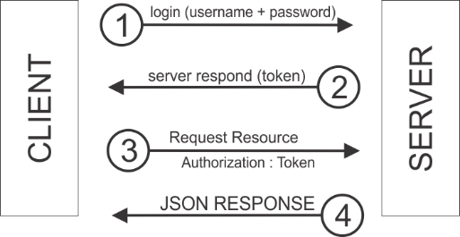
Figure 2.1 Illustration of token authentication mechanism
The next development is the use of tokens as authentication. This method is claimed to be more secure than the previous 2 methods because it does not use username and password. The authentication process in this method can be seen in Figure 2.1. First, the client makes a request to the server using a username and password. The server will provide a token response. This token will be used by any client application to request a resource request to the server. Token is random and does not relate to any existing client data so it is more secure.
This method is also called Token-Based Access Control (TBAC). The TBAC system is based on reusable and reconfigurable tokens to provide resource access to specific users. Token can be configured to only view the required resources without showing the identity of the owner of the resource. The advantages of this method, the token used can be modified and removed without affecting the organizational structure making it easier in performing system maintenance

CHAPTER III
METHOD

3.1 Tool and Material

3.1.1 Tool of Research
The tools used in this research include:
- Notebook with Windows operating system 10, Dual Core @ 2 Ghz processor, 4 GB memory and 320 GB hard drive.
- PHP programming language.
- Slim Framework, the framework used to create REST system.
- Atom as a text editor in developing the system.
- XAMPP, server software that contains Apache, MySQL and FTP services.
- PHPMyadmin is used as an interface in database management.
- Postman is used as a testing application in request resource URI
- Apache JMeter is used as a testing application to perform performance tests

3.1.2 Material
The material used in this research is smartfarm system API along with simulated data resource from sensor that has been made in previous research. The method of taking the research material is done by doing face-to-face directly with the previous researcher [4].

3.2 Research Flow

System Requirement Analysis
In this research, the API system will be developed again by adding the function of authentication and user management. Illustration of the development of new functions can be seen in Figure 3.1. In the picture can see the big picture of the API system on the smart farm. While the development of this research focus on the red box that contains the functions of authentication and user management.
.
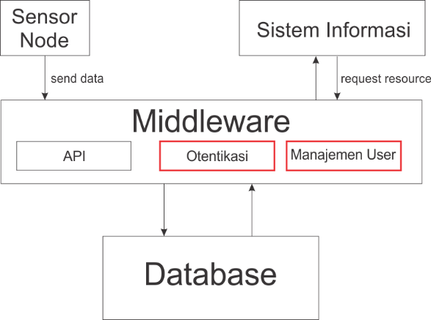
Figure 3.1 Services to be developed within the smartfarm API

Authentication service is a service used to filter the incoming requests to middleware. While the user management service will work set the user permissions to view the resources on the database

System Planning
In this system will be built 2 main services namely authentication services and user management. Figure 3.2 is an illustration of the designed token system architecture. Authorization server is a server that serves to store user data. While the server resource is a server that represents the resource of the smartfarm system.
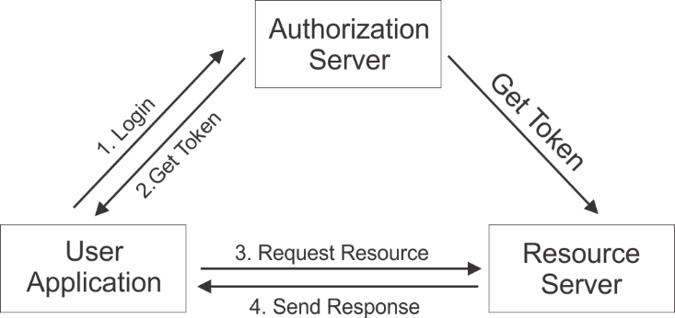
Figure 3.2 Token System Architecture
Every time a user logs in, the system will generate a generate token function to generate a new token value and update for expiry_time. The value of expiry_time will increase 10 minutes each time the user logs in. Token obtained by the user will be different in every login process. This is intended to increase the security value of this system. Once the token is obtained, it will be used by the user to request the resource in the system. Illustrations of the use of Fire Key can be seen in Figure 3.3.
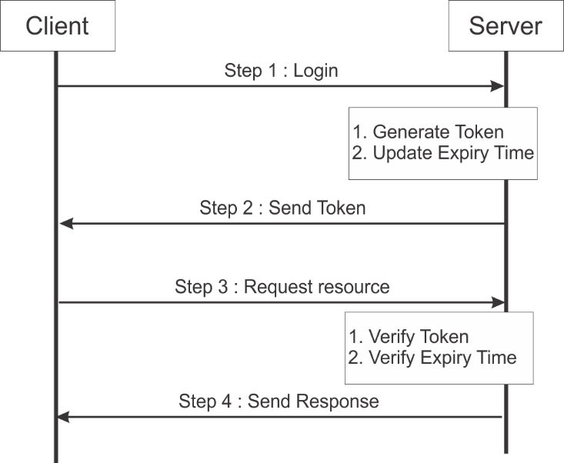
Figure 3.3 Illustration of token usage
User management services consist of User Registration, User Activation and User Login. To facilitate the development of the API then also designed URI to manage this process. The design of URI for user management services can be seen in Table 3.1. At the time of registration, users need to enter data such as username, name, email and password by accessing URI / register.
Table 3.1 URI design for user management services
No | Service | URI Design
1 | User Registration | /register
2 | User Activation | /activate/:id
3 | User Login | /login

CHAPTER IV
RESULT

4.1 Result
In this research, there are 2 tests. The first test by the Black Box testing method [10]. The second test is performance analysis. The authentication service created will be compared to the previous system that has not yet used token authentication. The comparable value is response time.
The first test is performed on the token authentication service. In this token authentication service there are 4 scenarios tested. URI to be tested is / alerts that represent resource table alerts in the database. In the previous system if the user request on URI / alerts then the system will directly restore the requested data. In the new system, the request will be validated in advance if there is a token in the request header. If the token is present and valid then the system will return the requested data.
Table 4.1 Token Authentication Service Testing Result
No | Test Scenario | Expected Result | Result
1 | Request a URI by not including a token | The API will return an error message containing information that the token was not found and did not process the request | Valid
2 | Make a request to the URI by including an incorrect token | The API will return an error message containing information that the token is wrong and does not process the request | Valid
3 | Make a request to the URI by including the appropriate token | The API will process the destination resource data in the URI | Valid
4 | Make a request on the URI by including the appropriate token but already expired | API will return timeout error message | Valid

From table 4.1 it can be concluded that has successfully developed token authentication service with 100% validity. API security is better because only requests from valid users have valid tokens being served. Request from user without token will be rejected by system.
The second test is measuring the response time time. Response time is the time required by the server to reply to requests from clients. From the test results in Table 4.7 obtained response time value for the old API system ranges from 150 ms. This value increases to 190 ms for API systems that have been using token authentication.
Table 4.2 Testing comparasion of response time
 | Without Token Authentication | With Token Authentication
50 Request | 155 ms | 199 ms
100 Request | 151 ms | 196 ms
150 Request | 154 ms | 197 ms
200 Request | 152 ms | 195 ms

CHAPTER V
SUMMARY AND SUGGESTION

Summary
After doing research with the development of authentication token theme and user management for internet system based on this restful matter then it can be concluded some point as follows:
- Token authentication and user authentication services have been developed with the addition of 5 services: registration service, user login service, user activation, token authentication service and user management service. Based on the results of the functionality test using 18 scenarios, the system has been proven to successfully meet the identified needs that have been determined in the needs analysis phase.
- The security of the API gets better because the use of token authentication makes resource access via URIs limited, only registered users and have tokens that can request
- Development of token-based user management has successfully restricted user permissions. Each user has their own privileges on sensor nodes

Suggestion
Suggestions that can be given author based on some research that has been done is as follows:
- The limitation of user management in this study is still limited to access to sensor node requests, need to be developed restrictions for request methods such as GET, POST, PUT and DELETE
- The role of users in this study is still limited to 2 roles ie admin and user as a normal user, need to be developed again to support other roles such as guest, landowners and workers

BIBLIOGRAPHY
[1] “Gartner Says 6.4 Billion Connected &quot;Things&quot; Will Be in Use in 2016, Up 30 Percent From 2015.” [Online]. Available: http://www.gartner.com/newsroom/id/3165317. [Accessed: 20-Mar-2017].
[2] “DDoS attack that disrupted internet was largest of its kind in history, experts say | Technology | The Guardian.” [Online]. Available: https://www.theguardian.com/technology/2016/oct/26/ddos-attack-dyn-mirai-botnet. [Accessed: 20-Mar-2017].
[3] S. Lee, J. Y. Jo, and Y. Kim, “A Method for secure RESTful web service,” 2015 IEEE/ACIS 14th Int. Conf. Comput. Inf. Sci. ICIS 2015 - Proc., pp. 77–81, 2015.
[4] A. Azis, “Pengembangan Restful API Untuk Mendukung Sistem Pemantauan Perkebunan Kelapa Sawit,”Skripsi, Jurusan Teknik Elektro dan Teknologi Informasi, Fakultas Teknik, Universitas Gadjah Mada, 2017.
[5] D. Peng, C. Li, and H. Huo, “An extended UsernameToken-based approach for REST-style Web Service Security Authentication,” Comput. Sci. Inf. Technol. 2009. ICCSIT 2009. 2nd IEEE Int. Conf., pp. 582–586, 2009.
[6] X. W. Huang, C. Y. Hsieh, C. H. Wu, and Y. C. Cheng, “A token-based user authentication mechanism for data exchange in RESTful API,” in Proceedings - 2015 18th International Conference on Network-Based Information Systems, NBiS 2015, 2015, pp. 601–606.
[7] D. Boneh and M. Franklin, “Identity-Based Encryption from the Weil Pairing,” SIAM J. Comput., vol. 32, no. 3, pp. 586–615, 2003.
[8] D. Chappell, “Claims-Based Identity for Windows an Introduction To Active Directory Federation Windows Identity Foundation,” Microsoft Corp., no. November, 2011.
[9] S. Lawrence and L. Stewart, HTTP Authentication : Basic dan Digest Access Authentication. 1999.
[10] L. Williams, “Testing Overview and Black-Box Testing Techniques,” Int. Conf. Softw. Eng. 2007, pp. 35–59, 2006.

